### Class Exercise #3 – Styles, Formatting, Quotations and Comments

**There are two parts to this assignment, Part I and II**

**--------------------------------------------------------------------------------------------------------------------------------------------------**

**Part I:** Instruction (completing this instruction –

1. Similar instruction to Class Exercise #1 and #2 instructions, addition steps are 5 and 6.

2. Please use MS Windows 10 Snipping Tool to take screen shot of the following Tasks, **make sure it is legible and readable screen shot.**

2. Please put your full name in the header.

3. Please do not modify this document to another format, keep as MS Word with .docx.

4. Submit this document to eCampus > Submit Your Assignment Here > Class Exercise #3 Submit Here. Refer to the syllabi for due date.

5. In this assignment you will two parts, Part I, as follows:

Part I has three tasks:

* Task A – create the **styles.html**
* Task B – create the **formatting.html**
* Task C – create the **quotations.html**

6. In regards to your index.html page, link the index page to the three webpages (style.html, Formattinging.html and Quoatations.html), please place three three web pages under the Assignment column, provide description to each under the Description column and include the date when you did this, when you link from your index page to these three pages, please use the attribute target = “_blank” inside your anchor element, using FileZilla FTP account information, to your web directory.

7. After you have completed the style.html, formatting.html and quotations.html files, save it inside ClassEx3 sub directory, please upload your local file structure from your local computer to the web server.

Here’s my local drive:

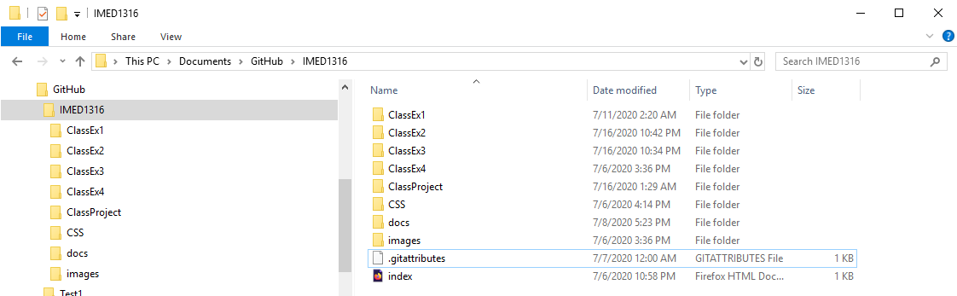

Note: index.html is the only file that is sitting at the same level as ClassEx1, ClassEx2, etc. and other sub directories. I know that the video demonstrate a folder with four number as a date, please don’t use those folder names, keep what I ask you like the above screen shot. Here’s an example of one of web8388 account:

Please note the sub directories are “mirror” from the local drive and web server drive. Index.html is the only file sitting at the same level as the other sub directories, no other files. Please organize it this way, deduction of points if it does not organized like this.

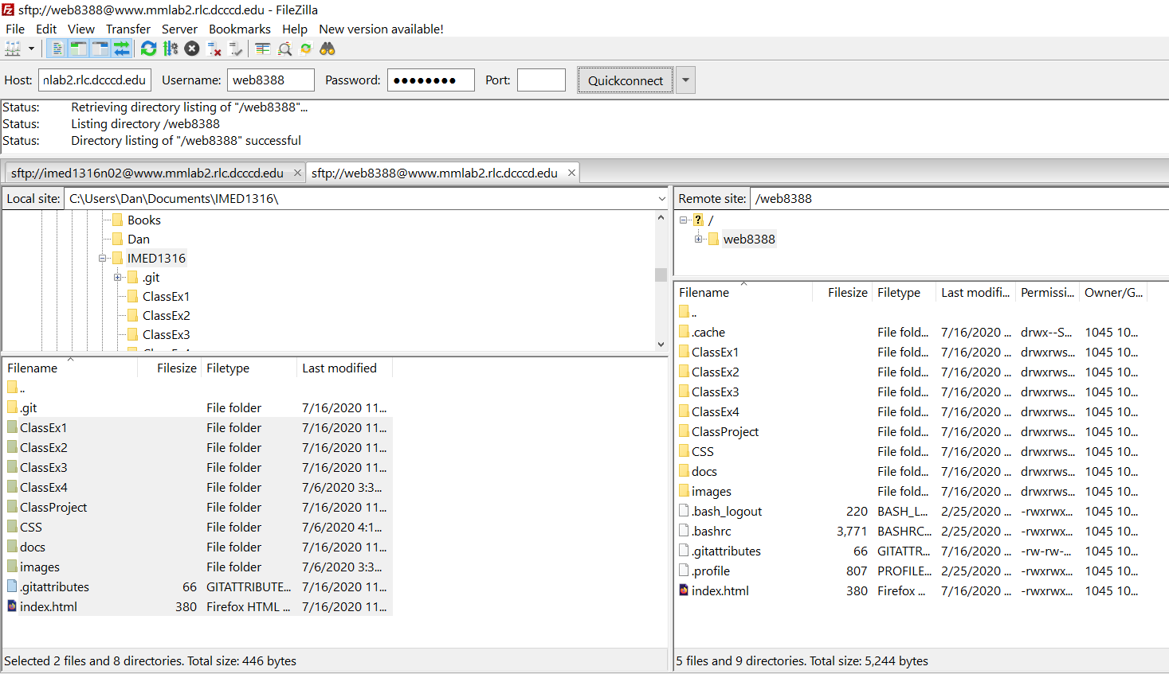

You will need to connect to Filezilla FTP to webserver and select the all the sub directories and files. Select, drag and drop the from the left window (local drive) to the right window (web server).

Update your index page with date, description and link to the html file to each of the Tasks. You will need to link from your index page to the three html files(styles, formatting and quotation.html files), and back to the index page from all three files.

Please save all .html and asset files inside the ClassEx3 sub directory.

-----------------------------------------------------------------------------------------------------------------------------------------

You will need to follow the sequential steps from Task A, B, C, etc…. to complete this assignment.

### Task A: styles.html

1. With MS Visual Code, the video could have create the html document and save as **styles.html**.

2. Create a sub directory with today’s date, i.e. 020920, this date will vary based on when you do this. Save the styles.html file inside this subdirectory.

3. Watch this video:

Class Exercise #3 – Part 1: <https://www.youtube.com/watch?v=xX9_7_9-OI8>

Class Exercise #3 – Part 2: <https://www.youtube.com/watch?v=MXZGygD-G3s>

NOTE: the video is done with Notepad IDE, the same code can be done in MS Visual Code, please create this using MS Visual Code.

4. Take screen shot of your styles.html, if it too long, you might have to take several screens shot with the Snipping Tool, copy/paste below.

### Task B: formatting.html

1. With notepad, create the html document and save as **formatting.html**.

2. Create a sub directory with today’s date, i.e. 020920, this date will vary based on when you do this. Save the styles.html file inside this subdirectory.

3. Watch this video:

Class Exercise #3 – Part 3: <https://www.youtube.com/watch?v=KqboR1mNBOQ>

Class Exercise #4 – Part 4: <https://www.youtube.com/watch?v=YIpdnTvBiOw>

4. Take screen shot of your formatting.html, if it too long, you might have to take several screens shot with the Snipping Tool, copy/paste below.

### Task C: quotations.html

1. With notepad, create the html document and save as **quotations.html**.

2. Create a sub directory with today’s date, i.e. 020920, this date will vary based on when you do this. Save the styles.html file inside this subdirectory.

3. Watch this video:

Class Exercise #4 – Part 5: <https://www.youtube.com/watch?v=5vNnszCzX9g>

Class Exercise #4 – Part 6: <https://www.youtube.com/watch?v=-HROMz_sLcw>

4. Take screen shot of your formatting.html, if it too long, you might have to take several screens shot with the Snipping Tool, copy/paste below.



----------------------------------------------------------------------------------------------------------------------------------------------

**Class Exercise #3 – Part 2 starts here**

Instruction (completing this instruction – 50/50 points):

1. Similar instruction to Class Exercise #1, #2 and #3 instructions, addition instruction on #8

2. Please use MS Windows 10 Snipping Tool to take screen shot of the following Tasks, **make sure it is legible and readable screen shot.**

3. Please put your full name in the header.

4. Please do not modify this document to another format, keep as MS Word with .docx.

5. Submit this document to eCampus > Submit Your Assignment Here > Class Exercise #3 Submit Here. Refer to the syllabi for due date.

6. In this assignment you will create four html documents, as follows:

* Task A – install Visual Studio Code (Assume you complete this all ready)
* Task B – create the **colors.html**
* Task C – create fictional eCommerce webpages
* Task D – create the **css_1.html** (demonstrate the inline CSS)
* Task E – create the **css_2.html** (demonstrate the internal or embedded CSS)
* Task F – create the **css_3.html** (demonstrate the external CSS)

Please put all of the html files in ClassEx3 sub directories.

7. In regards to your index.html page, **link the index page to the all webpages in step #6 above**, like you did for Class Exercise #1 and #2, the index.html to basic.html and link back from basic.html to index.html.

Please write a description for each as assignment in your own words.

I shouldn’t use the back or forward-arrow buttons for navigation.

8. Please place all web pages under the Assignment column, provide description to each under the Description column and include the date when you did this, when you link from your index page to these webpages and back to index.html, post your Class Exercise assignment, link it from your index.html page, please use the attribute target = “_blank” inside your anchor element, using FileZilla FTP account information, to your web directory.

8. 7. Please upload your local file structure from your local computer to the web server.

Here’s my local drive:



Note: index.html is the only file that is sitting at the same level as ClassEx1, ClassEx2, etc. and other sub directories. I know that the video demonstrate a folder with four number as a date, please don’t use those folder names, keep what I ask you like the above screen shot. Here’s an example of one of web8388 account:

Please note the sub directories are “mirror” from the local drive and web server drive. Index.html is the only file sitting at the same level as the other sub directories, no other files. Please organize it this way, deduction of points if it does not organized like this.



You will need to connect to Filezilla FTP to webserver and select the all the sub directories and files. Select, drag and drop the from the left window (local drive) to the right window (web server)

Update your index page with date, description and link to the html file to each of the Tasks.

Please save all .html and asset files inside the ClassEx3 sub directory.

-----------------------------------------------------------------------------------------------------------------------------------------

You will need to follow the sequential steps from Task A, B, C, …F, etc…. to complete this assignment.

### Task A: Install Visual Studio Code (Online section only) – Refer to eCampus > Lecture and Labs Information Class Exercise #1 - Task C - FTP Connection section.

~~1. Please watch this video:~~ [~~https://www.youtube.com/watch?v=dkCii5Gdubs~~](https://www.youtube.com/watch?v=dkCii5Gdubs)

~~2. Create sub directory with today’s date, inside this subdirectory, create new~~ **~~helloWorld.html~~** ~~document with the proper HTML elements and tags, save it and open in web browser. Using the Snipping Tool, take screen shot of the Hellow World! message in browser,~~ **~~copy/paste below~~**~~:~~

|  |
| --- |
| **NOTE: From Task B on forward and rest of this course, we will be using Visual Studio Code** |

### Task B: HTML Color

1. Please watch this video:

HTML Color – Part 1: <https://www.youtube.com/watch?v=-lzvujE7OMQ>

HTML Color – Part 2: <https://www.youtube.com/watch?v=HmfAKe4LprA>

HTML Color – Part 3: <https://www.youtube.com/watch?v=ZQL1xOz6eh4>

2. Create a sub directory with today’s date, i.e. 020920, this date will vary based on when you do this. Save the **colors.html** file inside this subdirectory.

3. Take screen shot of the colors.html in the web browsers, copy/paste below:

### Task C: Create a fictional eCommerce webpages

1. Watch this video: <https://www.youtube.com/watch?v=uC0sQ7P5LTo>

2. Inside ClassEx3, create a sub directory with today’s date, i.e. 020920, this date will vary based on when you do this. Save the template.html file inside this subdirectory.

3. Assuming that you have all the proper links for Home, Produtcts and Contact Us pages.

4. Link from your index.html to the index.html (Home webpage inside your subdirectory), and create a link from your Home page (index.html) back to your main index.html default page.

5. Make sure all links are proper link with no broken link, between the Home, Products, and Contact Us pages. More important the navigation do not move.

### Task D: Inline CSS

1. Watch this video on Inline CSS: <https://www.youtube.com/watch?v=2WOlOHdPRmI>

2. In the web browser, take screen shot of your **css_1.html**, if it too long, you might have to take several screens shot with the Snipping Tool, copy/paste below.

### Task E: Internal or Embedded CSS

1. Watch this video on internal (embedded) CSS: <https://www.youtube.com/watch?v=H-vAhV-Zc1E>

2. In the web browser, take screen of your **css_2.html**, if it too long, you might have to take several screens shot with the Snipping Tool, copy/paste below.

### Task F: External CSS

1. Watch this video on external CSS:

External CSS Part 1: <https://www.youtube.com/watch?v=VCA6ovQV3T0>

External CSS Part 2: <https://www.youtube.com/watch?v=ACayMgR4CdI>

2. Make sure you create the css sub directory for the **styles.css** and **css_3.html** file properly links with the styles.css.

2. In the web browser, take screen shot of your **css_3.html**, if it too long, you might have to take several screens shot with the Snipping Tool, copy/paste below.

----------------------------------------------------------------------------------------------------------------------------------------------

**Task G – Finishing Touch**

**RECAP**:

After you watch all segments and complete all Tasks A, B, C, D, E and F, your last Task G, this task is to update your current index web page with the content we currently complete for this week, please refer to the course syllabi schedule to assistance. You need to include the follow to the index.html.

* link to Class Exercise #3 from your index page with a new tab open (recall target = “_blank”).
* Make sure all links work before I grade, points will be deducted for broken links.
* All .html screen shots are for all the tasks are taken in the web browsers, not the html code.
* All webpage from this assignment must be link to and from the index.html.
* Be sure your editor is Visual Studio Code, please do not use Notepad or any other Text Editor for this course.

**Please copy and paste your webpage URL in browser below:**

**http://www.mmlab2.rlc.dcccd.edu/imed1416-83840/web8520**

_____________________________________________________________________________________

**(NOTE: Please do not copy and paste your local drive path, I provided this URL with your FTP account information)**

**And**

**Please upload this document to eCampus > Submit All Assignment Here > Class Exercise #3 Submit Here** before due date!

Thanks, Dan.